Inception Report

Project identifier: WARDIP/2022/CS/QCBS007

26 June 2024

The project was funded by the World Bank

Document control

Project data

|  |  |
| --- | --- |
| Title | Consultancy for an E-Government Assessment, development of Policy and Roadmap |
| Contract Number | WARDIP/2022/CS/QCBS007 |
| Country of fulfilment | The Republic of Gambia |
| Beneficiary | Ministry of Communications and Digital Economy |
| Consortium Partners | AAM Management Information Consulting Ltd. – Nifty ICT Solutions Ltd. |

Authors

|  |  |
| --- | --- |
| Prepared by | Attila Kassai, Akos Szirmai |
| Quality assurance | Akos Szirmai |

Status of document

|  |  |  |
| --- | --- | --- |
| Submitted on | 26th June 2024 | |
| Version | 1.0 | |
| Status | Draft |  |
| For revision | X |
| For approval |  |
| Approved |  |

Change History

|  |  |  |  |
| --- | --- | --- | --- |
| Version | Date | Created by | Version description |
| 1.0 | 26th June 2024 | Ákos Szirmai | Submitted to MoCDE for review@ |
|  |  |  |  |
|  |  |  |  |
|  |  |  |  |

Table of Contents

1. Executive Summary 4

2. Introduction 6

2.1 Content and Coverage of the Inception Report 6

2.2 Activities of the Inception Phase 7

3. Project context 8

3.1 General background of e-Government operations in Gambia 8

3.2 Review/ Mapping of Regulatory Frameworks 8

3.3 Ongoing and Past Initiatives 9

3.4 Third-party Stakeholders 9

4. Project definition 12

4.1 General and Specific Objectives 12

4.2 Refined Project Scope 12

4.3 Boundary conditions, assumptions 13

5. Approach and methodology 13

5.1 Overall approach 13

5.2 Methods Used 16

5.3 Project Work Plan 17

6. Project organisation and staffing 18

6.1 Roles and responsibilities 18

7. Project management procedures 22

7.1 Project forums and communication 22

7.2 Project Status Reporting 25

7.3 Quality assurance and delivery acceptance 25

7.4 Decision-making Process 26

7.5 Project change control 27

7.6 Risk Management 27

7.7 Project administration and document management 29

7.7.1 Document management 29

7.7.2 Administration 30

8. Initial risk log 31

Annexes 33

A. Templates used for project management 33

A.1. Status report template 33

A.2. Meeting minutes template 35

A.1. Decision paper template 36

# Executive Summary

Having signed a contract, the Ministry of Communications and Digital Economy (MoCDE for short) and the consortium of AAM Management Information Consulting Ltd. and Nifty ICT Solutions Ltd. started a project to define a comprehensive e-government policy and roadmap.

After gathering information from the representatives of MoCDE, the Consultant’s team has prepared this Inception Report containing the conditions under which the Project will be executed. This Executive summary holds the most relevant information on the contents of the Inception Report.

Project definition

The scope and deliverables of the Project are laid down in the Terms of Reference and the Proposal of the Consultant. The final aim is to assist MoCDE’s aims to embark on a transformation process to digitalise governmental services. The tool for this objective is the operationalisation of the existing strategies and plans with the consideration of local and global best practices via the definition of a comprehensive Policy and a realistic Roadmap.

These goals are supported in the following phases:

* Definition of an Inception Report covering project context, scope, deliverables, overall schedule, roles & responsibilities, project procedures and risks by 24th June 2024
* Assessment of the Gambian e-government readiness and comparison with regional peers by
* submission of Regional and global best practices and case studies by 8th July
* submission of E-government readiness assessment and recommendations by 2nd September
* Development of a draft e-government policy and roadmap
* submission of Policy and Roadmap by 15th November
* Preparation and acceptance of a Closure Report by 2nd December

The above dates are the dates of the first submissions of given deliverables, allowing 10 working days for review and 5 working days for modifications afterwards.

Project organisation and procedures

A dedicated project organisation is set up with a three-level structure: Project supervision, project management and project execution. Project supervision is carried out by the Steering committee with members from MoCDE, from involved Ministries and Agencies and from the Consultant. Project management includes the appointed MoCDE Project manager, the Consortium’s Team leader and Operative Team Leader and the Technical Committee delegated by MoCDE. Project execution is mainly carried out by the key experts of the Consultant with the assistance of appointed MoCDE staff members.

Rules, responsibilities and procedures are defined inter alia for project communications, status reporting, quality assurance, deliverables acceptance and risk management.

The Consultant will prepare bi-weekly Status reports about the progress, tasks, issues and risks of the project.

Risks and assumptions

A detailed risk assessment was carried out. The top risks (risk events with lower risk levels are in Section 8). evaluated at the preparation of the Inception Report are the following:

|  |  |  |  |
| --- | --- | --- | --- |
| Description of risk event | Description of risk effect | Risk level | Handling |
| Change or fluctuation in the composition of stakeholders | Key stakeholders demonstrate minimal engagement or willingness to participate in project activities which may leas to delays and not optimal project outcomes | **high** | Identify the relevant motivation tools to involve stakeholders and maintain regular communication to highlight the project's benefits |
| Changes to the project requirements during the project | New requirements are introduced after project commencement leading to increased duration and budget overruns | **high** | Implementation of adequate project change management processes to assess and integrate changes effectively |
| The identification of relevant external stakeholders is not complete and/or their involvement encounters obstacles | e-Government development may affect the whole Gambian public sector in the long run. It is not possible to involve every potential stakeholder and the interests and intentions of such stakeholders may diverge.  This may lead to long acceptance procedure within the government and/or rework | **high** | Significant efforts will be devoted to the identification of stakeholders, based on directions of e-government developments. |

These risks will be handled via well-defined project management procedures and possibly new risks may emerge during the project course.

The major assumptions are the following:

* MoCDE communicates the importance of the project to all relevant stakeholders.
* Affected departments, specifically the e-Government Directorate delegate resources to the project and provide the necessary support to carry out the project work
* Stability of the stakeholders and external working environment is ensured, which could be shaped by political and economic circumstances, throughout the whole project.
* Information gathering about other governmental agencies, or other parties apart from the MoCDE is organised by MoCDE upon a request of the Consultant or MoCDE.

# Introduction

On 13th of May 2024, the Ministry of Communications and Digital Economy (MoCDE for short) the Consortium AAM Management Information Consulting Ltd and Nifty ICT Solutions Ltd. (the Consultant) entered into a contract with the subject of “*Consultancy for the development of the “E-Government Assessment and Roadmap and Policy Development*”. The contract was based on the proposal of the Consultant submitted earlier and is financed by the World Bank. The beneficiary of the project is the MoCDE. The project started officially on the 3rd of June 2024 and according to the plan, should be completed by the 3rd of December 2024.

## Content and Coverage of the Inception Report

This Inception Report sets the Scope, boundaries and conditions under which the project will be executed. It includes all the findings of the Inception Phase and is oriented to a deeper understanding of the circumstances, requirements and environment than what was stated in the Terms of References (ToR) and the proposal of the Consultant. The Inception Report is the first deliverable of the project. The other main goal of the Inception Report is to regulate the cooperation of the Client and the Consultant via a clear definition of project procedures and responsibilities.

The Inception Report extends the content of the Proposal of the Consultant (in alignment with the Contract) using the information revealed from consultations with the Client’s appointed staff members and from documents provided by the Client as well as publicly available material subjected to the client acceptance.

The main sections of the Inception Report are as follows:

* Project Context

This section describes the wider environment of the project which has an influence on the expectations and outcomes. Its goal is to define all external aspects to be considered during the diagnostic and policy formulation phases.

The ultimate question answered by this section is: **Why this project is executed?**

* Project Definition

This section describes the project boundaries by defining its required objectives, scope and results. Its goal is to unambiguously define MoCDE’s expectations and match them with the Consultant’s overall tasks.

The ultimate question answered by this section is: **What will the project achieve?**

* Approach and Methodology

This section describes the technical approach of the project itself by defining the methodologies. Its goal is to set a commonly accepted framework on how the goals set in the previous section will be achieved. It also includes the list of deliverables and the detailed work plan.

The ultimate question answered by this section is: **How will the results of the project be achieved?**

* Project Organization and Staffing

This section describes the roles and responsibilities of the project participants. Its goal is to have a common understanding of the tasks of the Client and the Consultant.

The ultimate question answered by this section is: **Who will contribute to the project and what?**

* Project Management Procedures

This section describes the project management approach used during the project. Its goal is to have a set of well-founded management procedures which ensure the smooth execution of the work plan resulting in high-quality deliverables within the time frame and handling all issues arising during execution.

The ultimate question answered by this section is: **How the project activities are carried out?**

* Project Risks and Assumptions

This section describes the risks associated with the project and its goal is to be prepared for the possible obstacles by defining measures that will be taken to reduce the probability or effects of the risk factors.

The ultimate question answered by this section is: **What are the major risks and assumptions under which the project is executed?**

## Activities of the Inception Phase

Starting the Inception phase, the project's technical and human environment was established at first. Project participants have been nominated by MoCDE and key stakeholders were identified.

Due to the relatively short time available for the Inception Phase, information exchange between the parties was based on electronic channels, and the first visit of the Consultants to the Gambia will succeed the submission of the Inception Report. consequently, the involvement of key stakeholders was partial: only employees of the Ministry were contacted.

The Consultant prepared the proposed structure of the Inception Report and got it reviewed by the MoCDE. A list of necessary input documents had been compiled by the Consultant and was handed over to MoCDE which in turn sent most of these documents to the Consultant.

The Inception Report was prepared using the information available in the ToR, the Proposal of the Consultant and the result of the preliminary processing of the gathered information. Inception Report serves mainly as a repository of information and not as a detailed vehicle of analysis. Detailed fact-checking of received information will occur during the assessment of e-government.

# Project context

## General background of e-Government operations in Gambia

In recent years the Gambia dedicated significant effort and resources to promoting the transformation to a digital economy. This also implies the development of good quality and easy-to-access public services. Several initiatives were started, some focusing on the overall digitalisation scene and some putting emphasis on particular segments of the digital economy and government.

The current key documents are the “*National Digital Economy Master Plan 2024-2034*” document with a long-term strategic focus on the development path of the whole Gambian economy and society, and the “*e-Government Strategy 2021-2024*” document with a shorter-term focus on the digitalisation of particular governmental services.

Nevertheless, these strategic-level documents need a well-founded and comprehensive policy to enable the realisation of the strategic objectives even on a short time horizon.

## Review/ Mapping of Regulatory Frameworks

The following table lists the major regulatory elements (laws, bylaws)

|  |  |  |  |  |
| --- | --- | --- | --- | --- |
| Item reference | Status | In force since | Type | Scope |
| Information and Communications Act, No. 2 of 2009 | enacted | 29th May 2009 | Act | Regulation for:   * authorisation of information and communication systems and services, issuing licences, ensuring competition, providing access and enabling interconnection, management of frequencies, provision of access and services, protect personal data, etc. * fighting fraudulent use of computer equipment, handling electronic records and digital signatures, managing electronic transactions, providing e-government services, regulating service providers * broadcasting services (*not detailed* here) |
| Gambia Information and Communication Technology Agency Act, No. 3 of 2019 | enacted | 29th October 2019 | Act | Regulation for:   * Establishment of The Gambia Information and Communication Technology Agency for the operationalisation of e-government strategic initiatives and policies * Management and administration of the Agency |
| Access to Information Act, No. 0 of 2021 | enacted | 25th August 2021 | Act | Regulation for:   * Ensuring access to information of public bodies, exemptions from the general rules * Establishment of Information Commission and its powers and duties |

In the Gambia, although privacy is protected by the Constitution, there is no enacted Data Protection Act. The draft Act is under revision and acceptance.

Similarly, there is a National Cybersecurity Policy issued by the former Ministry of Information and Communication Infrastructure, but the Cybercrime bill is under revision and acceptance.

## Ongoing and Past Initiatives

The current Project is founded on the results of several preliminary strategic and tactical-level studies, strategies and specific action plans. These were developed to promote the digital transformation of the Gambia and include inter alia:

* e-Government Strategy 2021-2024
* National Digital Economy Master Plan 2024-2034
* National Information and Communication Infrastructure Policy 2017-2025
* The Gambia ICT4D Policy Statement 2018-2028
* Digital Transformation Strategy for the Gambia 2023-2028

In some areas, particular strategies, roadmaps and plans were developed including the following:

* Broadband network and access
* Cloud services
* Cybersecurity
* Data protection and privacy
* Digital ID
* Digital literacy
* Governmental open data
* Human capital development through ICT
* Private sector development through ICT
* Science, technology and innovation
* Youth and women development through ICT

These documents will be processed and analysed during the e-government readiness assessment phase together with the most influential ongoing and planned projects, which are summarised in the following table:

| Project | Description | Status |
| --- | --- | --- |
| Public Service Implementation | Implementation of 5 selected services (Passport, National ID, Driver’s License, Birth Certificate, Business Registration) as | Owner agency: GICTA  The process modelling of the 5 selected processes is ongoing.  Stakeholders: Ministry of Interior  Ministry of Justice |
| Digital Transformation Strategy for The Gambia 2023-2028 | The Digital Transformation Strategy is the breakdown of the National ICT Development Policy specific, concrete action items | Owner agency MoCDE  The draft Strategy is prepared and is under review. |
| National Digital ID implementation | One of the flagship projects of the Digital Transformation Strategy to introduce and roll out a digital identity card | Owner agency: MoCDE  Stakeholder: Ministry of Interior |
| Government Payment gateway development | Implement a robust national payment gateway to promote digital financial services. | Owner agency: Ministry of Finance / Accountant General Department |

## Third-party Stakeholders

This section lists the stakeholder organisations and groups (apart from MoCDE).

Key Stakeholders

Key stakeholders are directly responsible or involved in e-government service definition, implementation, provision and usage.

1. Natural and legal persons utilising public services
2. Public agencies which provide e-governmental services or public services with the potential of converting them to e-governmental services
3. Actors taking part in the definition, implementation and operation of e-governmental services.

The key external stakeholders

1. World Bank (including WARDIP project)

World Bank is one of the key sponsor organisations providing funds for e-government implementation activities in The Gambia.

1. Western Africa Regional Digital Integration Program (WARDIP project)

A project financed by the World Bank covering four countries in West Africa to jointly develop and integrate digital markets in the participating countries.

1. The Gambia ICT Agency (GICTA)

Public Agency founded in 2019 by the “*Gambia Information and Communication Technology Agency Act*” as the responsible institution to promote the use of information and communication technologies, including e-government services under the regulatory umbrella of MoCDE.

1. Ministry of Interior

Ministry responsible for ensuring

1. Ministry of Public Service

The Ministry is responsible for developing, managing and administering government policies and procedures for service delivery for citizens and legal persons.

1. Ministry of Justice

The Ministry is responsible inter alia for the legislative drafting of government bills and for the maintenance of several state registers including deeds, marriages, etc. and registers related to various legal persons.

1. Ministry of Health

The Ministry is responsible inter alia for the legislative drafting of government bills and for the maintenance of several state registers including deeds, marriages, etc. and registers related to various legal persons.

1. Ministry of Trade, Industry, Regional Integration and Employment

The Ministry is a strong candidate for implementing important e-government services and is promoting inter alia the modernisation process in industry, trade and the labour market.

1. Ministry of Finance and Economic Affairs

The Ministry is an important stakeholder in the digitalisation transformation of the Gambia, taking responsibility for the creation of the governmental payment gateway.

1. Information Technology Association in Gambia (ITAG)

The organisation of ICT professionals (as individuals, corporations or educational institutions) in the Gambia which was formed to promote the development and use of ICT in the country. There is a cooperation between ITAG and MoCDE.

1. General Public (natural and legal persons)

As the potential beneficiaries of e-government servicesITAG, the individuals, corporations and non-governmental organisations are the end-users of the offered services. for these groups access, ease of use, trustworthiness and reliability have distinctive roles.

# Project definition

As mentioned earlier, the objectives, expectations, tasks, deliverables and offered services in this Inception Report are applicable to the Consulting Project based on the ToR and contract between MoCDE and AAM Consulting Ltd.

## General and Specific Objectives

General Objectives

The overall objective of the WARDIP project is to promote the integration of digital markets in Western Africa by eliminating barriers to cross-border telecommunication services, increasing bandwidth in the region, supporting reforms to enable cross-border services, and especially fostering the development of reliable and robust e-government services.

Specific Objectives

The specific objective of this assignment is to support the implementation of the e-government strategic initiatives by developing a comprehensive e-government policy accompanied by a realistic implementation roadmap and action plan. The developed policy and roadmap must take into consideration the current e-government situation in the Gambia and the regional best practices.

## Refined Project Scope

The ToR formulated the requirements towards the Consultant. The major deliverables are the following:

| ID | Deliverable | Description |
| --- | --- | --- |
| D1 | Inception Report | The Inception Report reassures the project scope and deliverables and sets the conditions under which the project is executed. |
| M1.1 | Summary Report on selected Regional and Global best practices and case studies | The report will contain a high-level evaluation of the e-government situation in the selected peer countries (Guinea-Bissau, Guinea (Conakry), Liberia and Togo. The evaluation will follow the same 10 major aspects as the assessment of the Gambian situation (see later).  Moreover, the Report will contain other selected relevant best practices and preconditions of successful e-government implementation journeys. |
| D2 | E-government Readiness Assessment Report | The report will contain the evaluation of the current Gambian e-government situation using the 10 major aspects of the World Bank’s digital Government Readiness Assessment Toolkit (DGRA) method. It will also cover the current needs, priorities, gaps and challenges in the field of G2G, G2B and G2C services.  During the preparation of the Report, several working group sessions and consultation workshops will be held. |
| D3 | E-government Policy & Roadmap | The document will address the challenges derived from the Assessment Report with the considerations obtained from the Best practices and it will operationalise the e-governmental strategic objectives by breaking them down into well-defined activities with clear goals, means and responsibilities. |
| D4 | Final Report | The Final Report will contain the evaluation of the project and identification of follow-up activities. |

## Boundary conditions, assumptions

An assumption is a circumstance or event that must occur for the project to be successful, and that we believe is likely to happen. In other words, if it does not happen then it could jeopardise the success of the project. In this section, the assumptions for the successful development and implementation of all the project activities are listed. Any deviation from these assumptions may initiate a Change Request procedure.

* Adequate human and financial resources of MoCDE are in place, assuring thus a smooth project implementation, specialists are appointed to work with the consultant.
* MoCDE communicates the importance of the project to all relevant stakeholders.
* Affected departments, specifically the e-Government Directorate delegate resources to the project and provide the necessary support to carry out the project work (availability for interviews and workshops, willingness to share information and documentation about current processes, openness to participate in defining recommendations etc.).
* Background information on the selected benchmark countries is available.
* MoCDE will be available to discuss and decide on the final scope of each activity, communicate their needs and expectations
* Stability of the stakeholders and external working environment is ensured, which could be shaped by political and economic circumstances, throughout the whole project.
* Stability and availability of qualified staff and experts are ensured, including staff with the necessary level of authority to make decisions, as and when required during the whole project lifecycle.
* Internal coordination and monitoring bodies will be established.
* All the necessary communication channels will be established within the project team and with other stakeholders.
* Requested information, background documentation, necessary documents and regulations are provided to the Consultant in the English language.
* Information required from other governmental agencies is acquired by MoCDE to support the project team.
* No travel within the Gambia is needed
* Information gathering about other governmental agencies, or other parties apart from the MoCDE is organised by MoCDE upon a request of the Consultant or MoCDE.
* Review by Client of the submitted documents is carried out within 10 working days from receipt. Reviews of various MoCDE staff members and external reviewers are consolidated into a single review document by MoCDE. All collisions between different reviews are resolved by MoCDE in this single review document or a review section is held together with the Consultant to resolve the collisions.
* Holiday schedules of key participants are shared and substitute staff members are appointed for the duration of absences.

# Approach and methodology

## Overall approach

The project shall be delivered in four phases as per the following description:

* Phase 0: Inception
* Phase 1: E-Government Readiness Assessment Report
* Regional and global best practices and case studies
* E-government readiness assessment and recommendations
* Phase 2: Development of a draft e-government policy and roadmap
* Phase 3: Closing

The following diagram demonstrates the deliverables of the project together with their relationship to each other and to acquired information.

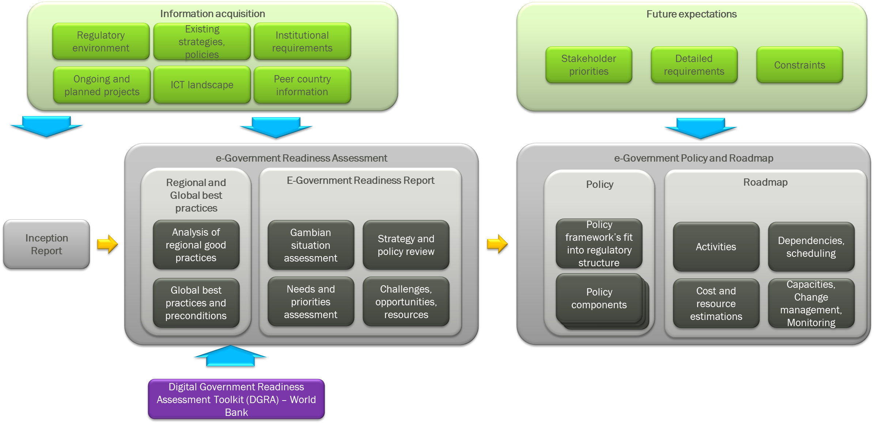

Diagram 1: Deliverables of the project and their relationships

## Methods Used

Assessment method

The primary tool for assessing the Gambian e-government readiness is the Digital Government Readiness Assessment (DGRA)[1] toolkit of the World Bank. This toolkit measures the maturity of the county from several viewpoints. The aspects are the following:

1. Leadership & funding / resource allocation
2. Interoperability, coordination & governance
3. User-driven design
4. Capabilities, culture & skills, change management
5. Technology infrastructure
6. Data infrastructure, strategy & governance
7. Legislation & regulation (including privacy)
8. Emergency response, resilience & cybersecurity
9. Digital ecosystem

These assessment aspects slightly differ from the aspects listed in the ToR, but will be “translated” to them by regrouping the sub-topics.

Information acquisition methods

More than one method will be used to reach information sources to acquire and validate the information. This approach shall provide a broader or deeper understanding of the data/information and “triangulate” the information acquired.

Diagram 2: Information acquisition methods

## Project Work Plan

The major milestones and delivery deadlines of the project are the following:

|  |  |  |
| --- | --- | --- |
| Deliverable | Phase/Activity | Deadline |
| Project start | – | 3rd June 2024 |
| D1: Inception Report | Inception | 24th June 2024 |
| M1.1: Summary Report on selected Regional and Global best practices and case studies | Assessment | 8th July 2024 |
| D2: E-government Readiness Assessment Report | Assessment | 2nd September 2024 |
| D3: E-government Policy & Roadmap | Policy & Roadmap | 15th November 2024 |
| D4: Final Report | Closure | 2nd December 2024 |

# Project organisation and staffing

The project's organisational structure was drafted in the proposal and was refined by interviews. The project organisation has three levels: Project Supervision, Project management and Project execution which are accompanied by the Organisational stakeholders forming the overall environment of the project as shown in the following diagram.

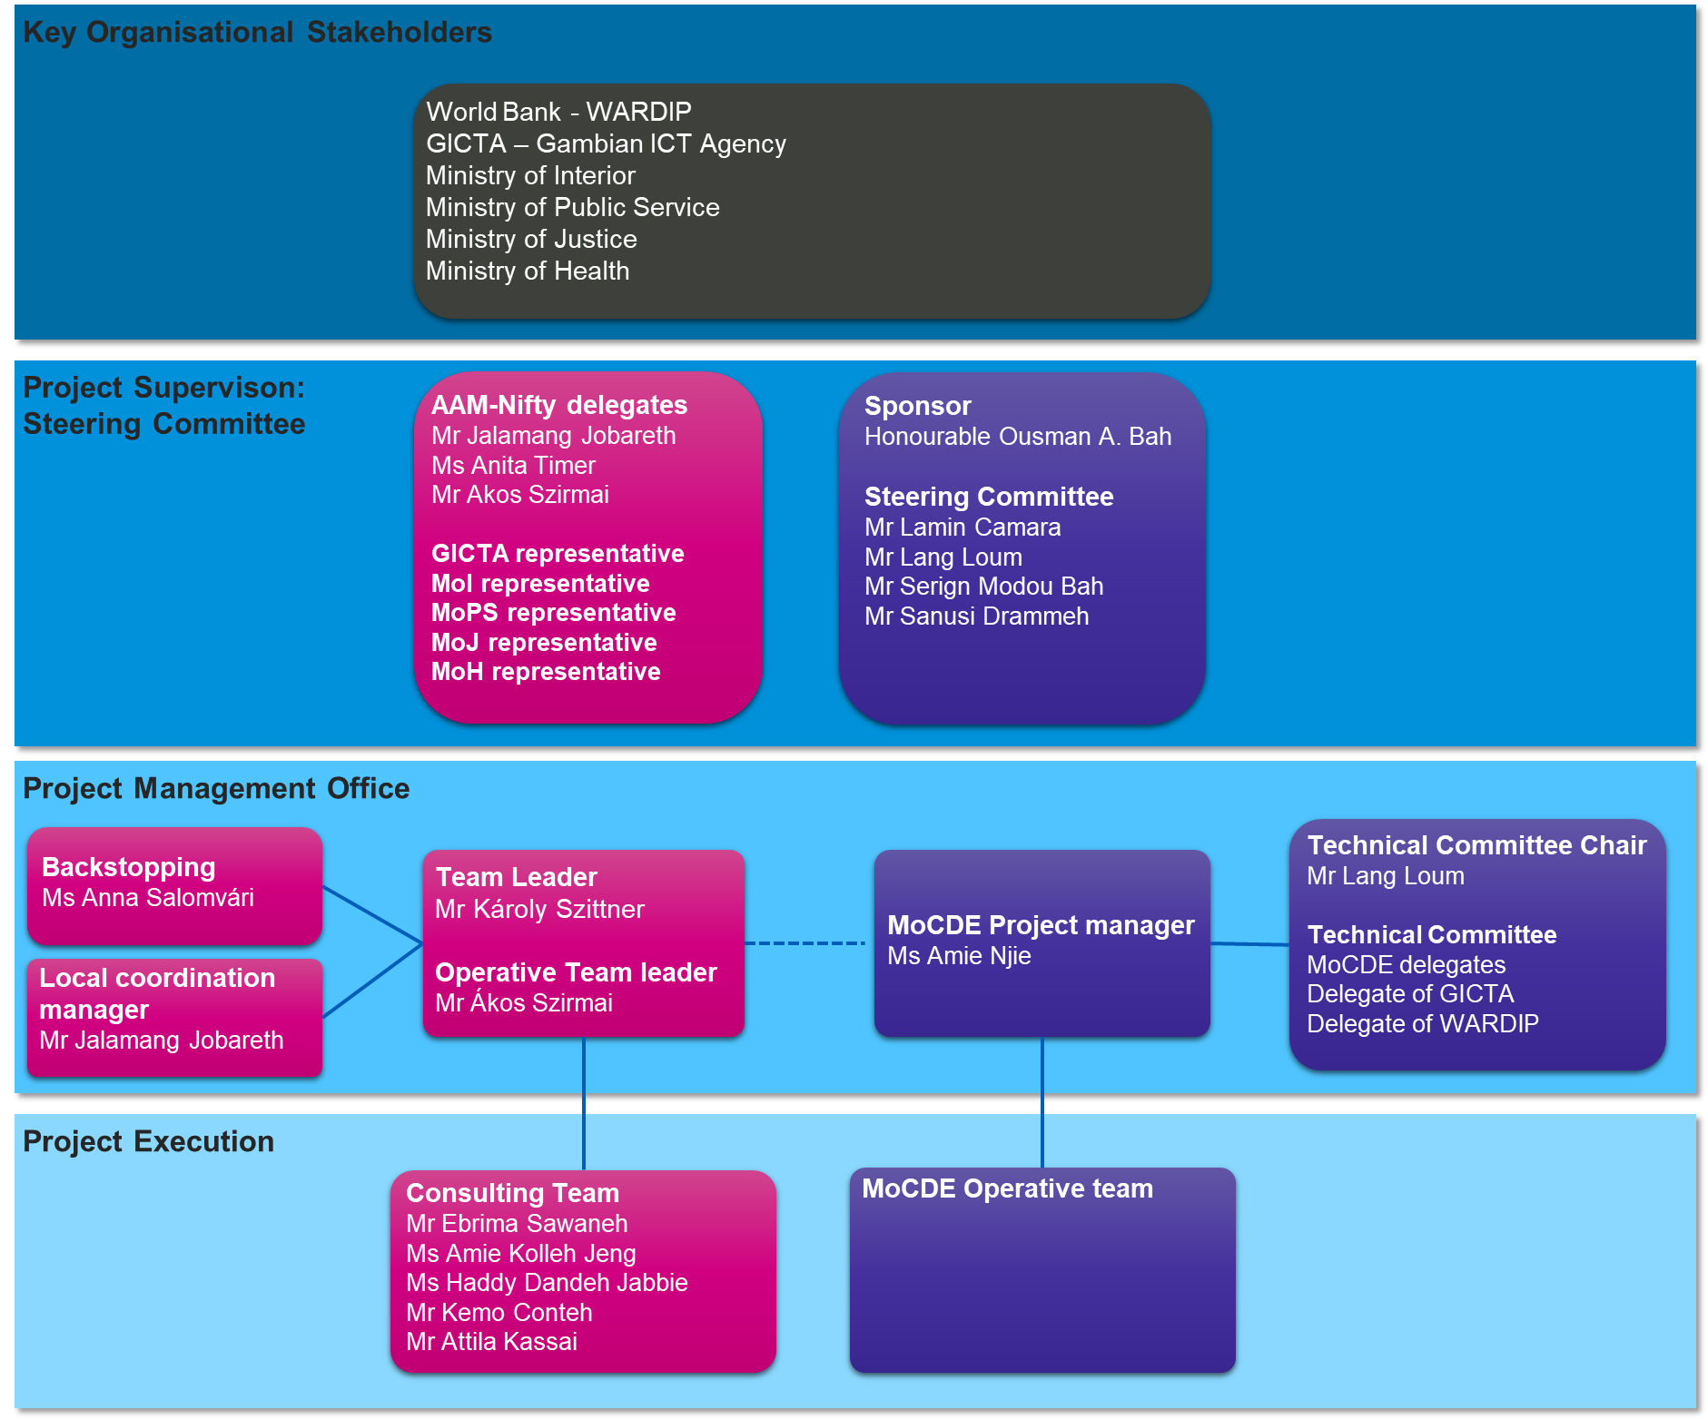

This Inception Report contains the roles and responsibilities of the Consultancy project.

## Roles and responsibilities

The section describes mainly the Roles and Responsibilities of the Consultancy project.

Project sponsor

The project sponsor is the “owner of the project” holding ultimate responsibility for the project.

The responsibilities of the project sponsor are the following:

* Hold executive responsibility for the project.
* Appoint and revoke MoCDE members of the Steering Committee and the MoCDE project manager.
* Invite external members of the Steering Committee.
* Call for, organise and chair Steering Committee sessions.
* Make business decisions and approvals escalated to the Steering Committee.
* Communicate the importance of the Project to MoCDE.
* Ensure participation and commitment of MoCDE members of the project.

Steering Committee

Group of dedicated people charged with regular oversight of the project and preparation for decisions on issues affecting the scope, timing and financial conditions of the project.

The responsibilities of the Steering Committee are the following:

* Review project status and monitor progress.
* Propose acceptance or rejection of deliverables.
* Make decisions and approvals escalated to the Steering Committee
* Handle the risks escalated to Steering Committee level,
* Document proceedings of the Steering Committee meetings.
* Accept deliverables of the project.
* Initiate contractual changes and manage contract modification if the need arises.
* Report project status to the external organisational stakeholders.
* Discuss and resolve Change Requests.

The Committee may invite project members including by request. The Project Sponsor chairs the Steering Committee.

Other external stakeholders

External stakeholders are the organisations or individuals outside of MoCDE who are either contributors to the project or are affected by project results. Involvement of contributors is through the Steering Committee or other communication channels, detailed in the communication section.

They bear no direct project responsibilities.

MoCDE Project manager

Appointed by MoCDE as a person responsible for project implementation, the MoCDE Project manager ensures smooth and proper cooperation between the Client and the Consultant. The main responsibilities of the MoCDE Project manager are the following:

* Ensure successful delivery of the various deliverables and phases of the project.
* Ensure the availability of required personnel for the project.
* Supply of required documentation to be processed by the Consultant.
* Review of Status reports.
* Organise and consolidate the reviews of the deliverables.
* Make decisions on issues not affecting the costs, scope and deadline of the project.
* Initiate decisions at the Steering Committee level if the issue is above his authority level.
* Advise/report progress and issues to the Steering Committee.
* Perform quality reviews at regular intervals.
* Detect, monitor and manage project risks.
* Identify and resolve issues.
* Manage stakeholder expectations.
* Monitor and report project budget and expenditures.
* Provide logistics support (local office space) for Consultants during Visits.
* Resolve potential conflicts within the MoCDE project team.
* Organise interviews and workshops with internal and external stakeholders.
* Ensure the availability of requested information and develop ways of obtaining necessary information with the Consultant.

Technical Committee

The Technical Committee consists of appointed staff members and invited external experts, who are the main reviewers of the deliverables. The main responsibilities of the team are:

* Review proposed draft skeleton documents and make recommendations on their content.
* Review deliverables of the documents and make recommendations on their content.
* Assist the MoCDE Project manager in making technical decisions related to the project.
* Form opinion on acceptance or rejection of deliverables to the Steering Committee based on the reviews.

MoCDE Operative team

The MoCDE Operative team consists of delegated staff members of MoCDE directly contributing to the project by providing information and opinions to the Consultant’s specialist. Their main responsibilities are:

* Provide information on the current situation and desired future state of e-government in The Gambia.
* Provide access to relevant documentation.
* Attend interviews and workshops.
* Review deliverables of the documents if requested, and make recommendations on their content and share their comments with the Technical Committee.

Consultant’s Operative Team leader

On behalf of the Consultant, the Team Leader’s responsibility is to ensure Consultancy project execution as planned in terms of quality, costs and deadlines.

The Team Leader will be responsible for the following:

* Provide overall methodological support for implementing the project
* Define the structure and content of the deliverable and initiate discussion on them with the Client
* Overview, coordinate and perform internal quality assurance activities.
* Address all comments and opinions of the MoCDE reviewers for the deliverables, submitted by the Consultant.

Consultant’s Operative Team leader

On behalf of the Consultant, the Operative Team Leader’s responsibility is to orchestrate the activities of the project team. Also, the Team Leader will be responsible for all issues related to the technical elements of the project but will always do this in consultation with the designated representatives of the Client.

The Operative Team Leader will be responsible for the following:

* Coordinate overall Consulting project activities.
* Ensure proper and sufficient resources from the Consultant’s side that are required to achieve the timely delivery of the project.
* Smooth and timely implementation of the project.
* Ensure proper reporting according to the Client’s requirements.
* Put in place a set of effective communication tools and means; directly communicate with the MoCDE project manager.
* Maintain the project Workplan and make necessary adjustments.
* Identify and evaluate risks and implement countermeasures to mitigate these risks.
* Identify and resolve issues.
* Manage stakeholder expectations.
* Detect changes, analyse their consequences and support decisions on Change Requests.
* Maintain the project documentation at the Consultant’s side.

Consulting Team

Key experts of the Consultant to carry out tasks and to develop documents necessary to complete the project in appropriate quality.

The consulting team is responsible for:

* With his/her best effort gather and analyse information, and develop deliverables of the project.
* Call the attention of the Consultant’s team leader to arising risks, and issues and propose action for their handling.

Local coordination manager of the Consultant

The Local coordination manager is responsible for the everyday contact between MoCDE and the Consultant. His main responsibilities include the following:

* Exchange physical documents (e.g. signed approvals for deliverables) between MoCDE and the Consultant.
* Keep contact with the MoCDE Project manager to organise local project events.
* Ensure team availability during the project and especially during local Visits.

Project Backstopping support

The Project Backstopping support arranges administrative means for the Consultant’s team. Her main responsibilities are:

* Provide administrative and logistics support for the Consultant’s team, especially during local Visits.

# Project management procedures

This section contains a detailed description of procedures related to the management and administration of the project. The procedures are aligned with the General and Special Conditions of Contract between MoCDE and the Consultant. Whenever there are any discrepancies between the Contract and the descriptions here, the contractual terms prevail.

## Project forums and communication

Communication has an essential role in the success of the project. Its role is to share knowledge and ideas related to the project between the parties.

Project communication has several layers, depending on the participants of communication. From a communication planning point of view, the following groups are distinguished:

1. Project team
2. External stakeholders involved in the project
3. External stakeholders not involved, but affected by project results
4. Internal stakeholders

These various stakeholder groups have different communication needs and are thus handled differently.

The major communication relations are depicted in the following diagram:

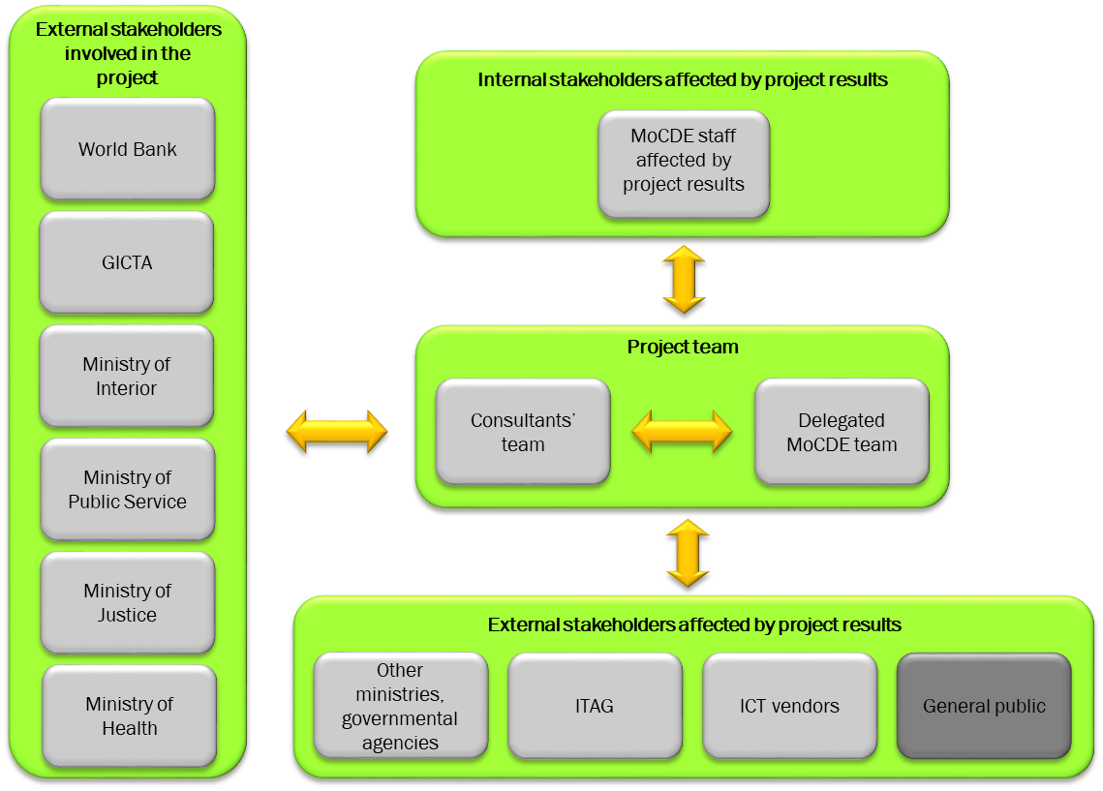

Diagram 3: Communication relations

Selected Ministries are directly involved in the project and are represented in the Steering Committee, other Ministries and governmental agencies will be consulted.

Communication beyond the level of individual Ministries (e.g. to the Government of the Gambia as a whole, or to the National Assembly) is out-of-scope of the project and is the full responsibility of MoCDE leadership.

The following table summarises the various forms of communication between the parties.

| Communication form | Goal | Parties/participants | Channel | Timing | Remarks |
| --- | --- | --- | --- | --- | --- |
| Communication within the project team | | | | | |
| Progress meeting | To share and discuss progress information, related issues, and risks and make decisions on items within the project boundaries | Client’s and Consultant’s Project Manager, other invitees | verbal on Teams | weekly | Detailed in 7.2 |
| Steering Committee meeting | To share and discuss progress information, related issues, and risks and make decisions on items affecting the project boundaries | Steering Committee members | face-to-face with the inclusion of remote members via Teams | at milestones or at request | – |
| Interviews | To gather information on specific areas from a few individuals | Employees or other experts of MoCDE and other involved institutions  Consultants | verbal face-to-face or remote (Teams) | at request | Interviews are arranged in advance by the MoCDE Project Manager. On request, the Consultant is responsible for preparing interview questions in advance and for sending them to the interviewee at least one day before the scheduled interviews. |
| Workshops | To gather information or opinions on specific areas from a wider group of individuals and to initiate discussion on certain topics. | Employees or other experts of MoCDE and other involved institutions  Consultants | verbal face-to-face or remote (Teams) | at request | In general, a group of experts of the Client is taking part in workshops.  Workshops are arranged in advance by the MoCDE Project Manager. The Consultant is responsible for making necessary preparations (presentations, questionnaires, etc.) for the workshop. |
| Technical Committee meetings | To give feedback on deliverables to the Consultant  To discuss any arising technical questions. | MoCDE reviewers (Technical Team) | written | on delivery or at request | In the case of MS Word documents, feedback is via Revision marks and comments. Reviewers are to be identifiable for the case of further clarification needs (Initials or names must be used during review) |
| Review session | To receive verbal feedback and clarification questions on the deliverables | MoCDE Project Manager and Consultant’s Team Leader  Reviewers of MoCDE  Other experts of the Consultant | verbal discussion (Teams) | at request | Organised whenever the review comments need further clarification or consolidation. |
| Review workshops | To receive verbal feedback and clarification questions on the deliverables | MoCDE and Consultant’s Project Manager  Reviewers of MoCDE  Other experts of the Consultant | verbal discussion (Teams) | at request | Organised whenever the review comments need further clarification or consolidation. |
| Bi-weekly progress report | To provide progress information, issues, and risks to the Project manager | Consultant’s Operative Team Leader | written report | bi-weekly | Detailed in Section 7.2 |
| Official correspondence related to the project | To notify the contractual parties on items affecting the fulfilment of the contract | Representatives of MoCDE and the Consultant | written signed letters delivered in scanned versions and by courier services | at request | Regulated by the Contract between the parties |
| Communication between the project team and other MoCDE stakeholders | | | | | |
| Awareness raising | To call the attention of the internal staff of MoCDE to the changes | Consultant’s team to recommend  MoCDE’s affected staff | to be decided | at request | The details of the communication messages will be outlined during the Implementation Roadmap |
| Communication between the project team and External stakeholders involved in the project | | | | | |
| Other external communication to involved stakeholders | To provide information about the status, goals and other items to involved external stakeholders (e.g. governmental agencies, and other stakeholders) | Client Project Manager  Steering Committee members  Representatives of other stakeholders | verbal or written | at request | The identification of information requests, channels and means for external stakeholders is the task of the Steering Committee.  The Consultant might be requested to contribute to the communication with relevant information, but the means of communication is up to SC members. |
| Sharing Project Status information | To obtain and provide information from and to other ongoing e-government initiatives | MoDCE Project Manager, MoCDE Technical Committee Chair  Consultant  Owners of other ongoing initiatives (sponsors, project managers) | verbal | 2-3 times during project course | – |
| Communication between the project team and External stakeholders affected by project results | | | | | |
| Other external communication to affected stakeholders | To provide information about the status, goals and other items to interested governmental agencies and other stakeholders | Project Sponsor  MoCDE Project Manager | verbal or written | at request | The identification of information requests, channels and means for external stakeholders is the task of MoCDE. The Consultant might be requested to contribute to the communication |
| Informing the general public | To inform the general public of the results of the project | MoCDE Project Sponsor | to be decided  (press release, press conference, publication on MoCDE homepage) | at project closure | The definition of major messages is part of the Policy and Roadmap development |

## Project Status Reporting

To keep the Client informed on the status and current issues of the project, a regular status report is prepared for the MoCDE Project Manager.

The basic approach to Project Status reporting:

* The Consultant’s Team leader will prepare status reports on a bi-weekly basis in order to present all finished tasks and activities, achievements, and requirements for the preceding 2 weeks, as well as problems, issues and risks.
* The template of the Status Report is in the Appendix.
* The Status Report is sent to the MoCDE Project manager every second Friday.
* The MoCDE Project manager reviews the Status Report and makes his comments within 2 days of receipt.

In addition to the above regular status reporting, special Status Reports may be requested by the Steering Committee. These special Status Reports are to be prepared by the MoCDE Project manager with the contribution of the Consultant’s Operative Team leader if required. The structure and the content are similar to that of the regular Status Reports, but the covered period is longer.

## Quality assurance and delivery acceptance

Quality assurance is a key domain of successful project execution. Its goal is to ensure the achievement of defined goals in terms of the content of the deliverables of the project. The approach to Quality assurance is the following:

* The structure and content of the individual deliverables are verified by MoCDE before the work starts on the given deliverable.
* General quality requirements are defined for the deliverables as:
* compliance of Project deliverables with the Contract,
* internal coherence of deliverables,
* deduction of later results from previous deliverables and other information,
* compliance with the methodology used,
* completeness of the deliverables.
* grammatical correctness.
* Having completed a deliverable, the Consultant’s Team Leader forwards the given deliverable to the QA personnel within the Consultant’s staff who reviews the document and makes remarks which are to be incorporated before the deliverable is sent to the Client.
* During the course of external quality assurance, the Client’s appointed staff members review the document and make their remarks.

The process is the following:

1. The deliverable is prepared by the Consultants and submitted in English to the MoCDE Project Manager in electronic form.
2. The MoCDE Project Manager distributes documents to reviewers of the Technical Committee who send their comments or their approval of contents within 10 (five) working days. The amendments and comments should be made using MS Word’s “Comment” and “Track changes” functions respectively. To be able to identify the various review files, the filenames for the reviewed documents are of the form: <#original file name> + “_” + <#monogram of the reviewer>.
3. The MoCDE Project Manager consolidates the reviewed documents into a single review document which contains all reviews. If this is technically problematic, then the individual review documents may be returned to the Consultant.
4. This consolidated review document is sent to the Consultant by the MoCDE Project Manager.
5. If the MoCDE does not send its comments within 10 working days, then the Consultant sends a reminder notification to the MoCDE Project Manager with whom a reasonable extension of the review period is agreed. If MoCDE does not send comments within this additional grace period, then the document shall be deemed approved. Parties agree that the grace period may affect the completion deadlines.
6. A review session is organised by the Consultant to discuss all findings, especially when the different reviewers have different opinions on an issue.
7. The Consultant makes the necessary modifications within 5 (five) working days and the modified document is submitted to the MoCDE Project Manager in English in electronic form with a clear indication of the changes and the reasoning behind them.
8. After the resubmission of the deliverable, the MoCDE Project Manager sends the modified deliverable to the Technical Committee members for check within 5 (three) working days.
9. If needed, then the modification/review cycle is repeated from step 3.
10. If the deliverable is accepted by the reviewers, then it is submitted to the Steering Committee for validation and approval.
11. The finalised and approved deliverables are printed and bound in 2 (two) copies, signed by the representatives of the Client and Consultant and handed over to the Client together with all electronic files needed to produce the deliverable (e.g. diagrams, worksheets, etc.).
12. The MoCDE Project Manager obtains a signed Acceptance Certificate from MoCDE and sends it to the Consultant’s Team leader manager within 5 (five) days from approval.
13. Upon receiving this approval, the Consultant may issue its invoice.

The Change control procedure is triggered whenever a late-arriving review makes modifying an already formally accepted document necessary.

It is important to note, that the governmental-level acceptance of the final documents (Policy and Roadmap) is beyond the scope of authority of the Consultant. Therefore, if such a procedure must be initiated, it is at the full discretion of the MoCDE and the act of formal governmental acceptance may not be regarded as the precondition of the fulfilment by the Consultant.

## Decision-making Process

During the course of the project, several project-related decisions may need to be made. There are two levels of decisions:

1. Decisions which are not affecting the boundaries of the project, that is the scope, final deadline and budget remain within the respective boundaries (Type 1 decisions). These decisions do not involve the amendment of the Contract.
2. Decision which may affect the scope, deadline or budget of the project (Type 2 decisions). These decisions involve the amendment of the Contract.

The basic approach to decision-making is the following:

* Whenever a request for a decision arises, the Consultant’s Team Leader assesses the level of decision according to the previous classification and together with the MoCDE Project Manager decides on the individual or group of individuals to make the decision.
* As a rule:
* For Type 1: Decisions are to be made by the MoCDE Project Manager,
* For Type 2: Decisions are to be made by the Steering Committee.
* For Type 2 decisions a Decision paper is prepared, demonstrating the background, the alternatives, the evaluation criteria, the evaluation of alternatives, the deadline for a decision and a recommendation as demonstrated in the template of the Appendix. For Type 1 decisions a Decision paper is prepared only by request of the involved.
* The person or group responsible for the decision may require additional information or analysis.
* If the decision is not made within the specified deadline, then Type 1 decisions are escalated to the Steering Committee.
* If Type 2 decisions are lagged, then they may directly affect the deadline of the Project.

## Project change control

Change management is needed whenever the concerned Parties experience alterations from what earlier was planned or stated in the Contract. In case the alteration has a relevant effect on the project, it shall be escalated and reported to the Steering Committee.

The basic approach to Change Control is the following:

* Any alterations affecting the scope of the project or any requests to modify the content of a previously accepted deliverable of the Project or any assumptions listed in the Proposal or in Section 5 not holding, is regarded as a Change.
* The Team Leader of the Consultant administers the Change request by providing the background and rationale of the change, the possible effects of accepting or denying (if applicable) the change and the estimated effects of the change on the schedule or the budget of the Change.
* If the change has no effect on the final deadline or the budget, then it is accepted or rejected by the MoCDE Project Manager.
* If the change has such effect, then the decision on the Changes is made by the Steering Committee which may request additional information supporting their decision.
* If the accepted change results in the modification of the Contract, then in accordance with the Contract, a written agreement is prepared between the Parties and signed by authorised representatives.

## Risk Management

Project risks are the issues, problems, and circumstances which threaten the achievement of project goals. Risk management means the timely recognition, evaluation and handling of risks. Its goal is to reduce the undesired effects of potential risks by recognising them well before the risk events occur, by reducing the probability of occurrence and by providing means to mitigate the effects.

The basic approach to risk management is the following:

* Using a uniform risk evaluation scheme, the Consultant’s Team Leader evaluates the risk factors and for all factors with a high enough risk he defines risk mitigation actions together with their responsible person and deadline.
* The initial risk factors and actions are listed in Section 8 of this Inception Report.
* The newly identified risk factors and the current status of the previously identified risks are summarised in the bi-weekly progress reports.
* Risk factors with high risk are escalated to the Steering Committee.
* Consultant’s Team Leader tracks risks and mitigation actions.

The evaluation of risk factors

The risk factors are evaluated from two different viewpoints:

* the effect of the risk on the project,
* the probability of occurrence.

The risk effects are classified as:

|  |  |
| --- | --- |
|  | Description |
| low effect | The occurrence of the risk event has only a minor effect on the project scope, or timeline and no effect on the budget |
| medium effect | The occurrence of the risk event may have a moderate effect on the project that is either   * some minor goals of the project are achieved with limitations or * the project deadline may be overrun by at most 4 weeks |
| high effect | The occurrence of the risk event might seriously endanger the project, that is either   * major goals of the project might not be reached or * the project deadline may be overrun by at least 4 weeks * project costs need to be increased |

The probabilities of the risks are classified as:

|  |  |
| --- | --- |
|  | Description |
| low | The occurrence of the risk event is not characteristic of similar projects or unlikely in the case of the e-Government project |
| medium | The occurrence of the risk event is regarded more or less as probable as its non-occurrence |
| high | The occurrence of the risk event is quite common in case of similar projects or according to circumstances it’s likely in the case of the e-Government project |

Since there are no available statistical data and analysis possibilities to determine the exact mathematical probabilities, the categories above heavily lean on subjective estimations based on previous experience on similar projects of the Consultant.

The combined risk is the combination of effect and probability as below:

|  |  |  |  |  |  |
| --- | --- | --- | --- | --- | --- |
| Probability | High | **Moderate** | **High** | **High** | |
| Medium | **Low** | **Moderate** | **High** | |
| Low | **Low** | **Low** | **Moderate** | |
|  |  | Low | Medium | High | |
|  | Effect | | | |

## Project administration and document management

### Document management

The Project uses and generates documents in a large number which makes the clear storage and usage rules essential. The basic goal is to provide an administrative and document management solution, which enables the Consultant to search for and access project documentation easily with clear identification of the current and past versions of the documents.

The rules applied to document management are the following:

* Documents of the project are delivered primarily in electronic format.
* Paper-based documents (invoices, signed Approval for acceptance documents, official letters) are to be stored in Binders and/or scanned if required independently by the Client and the Consultant.
* Electronic documents are created using the Microsoft Office 365 document formats (.docx, .xlsx, .pptx) and Adobe Acrobat format (.pdf); Diagrams are prepared with the DrawIO[2] tool.
* Documents are prepared using document templates.
* All documents created by the Consultant shall have a document identification section containing at least the title, day of submission and file name of the document.
* The reports generated shall hold a detailed Document Control section with the project data, authors, document status (Draft, for Review, for Approval, Approved) and change history of the document. Change history includes all major changes together with a unique version number identifying the underlying document version.
* Filenames of electronic documents may contain only alphanumerical characters and special characters of: ‘A’-‘Z’, ‘0’-‘9’, ‘_’, ‘.’, (the usage of blank spaces should be avoided);
* Filenames of documents prepared by the Consultant have the following structure: <#project identifier><#descriptive name>_<#version>_<#date of creation>_<optional: #additional review marker with initials> (i.e. GAEGOV01_Inception_Report_v1.0_20240620_AN.docx – version 1.0 of the Inception Report, submitted on 20th June 2024 and reviewed/commented by Amie Njie).
* Version number and submission date is assigned by the Consultant. The first digits of the version number refer to the major release, second digits refer to minor modifications.
* The electronic documents sent and received by the Client are maintained by the MoCDE Project Manager.
* Whenever classified information is included in any documents received from the Client or created by the Consultant, the MoCDE Project Manager and the Consultant’s Team Leader agree on the rules for handling classified information, which must be aligned with the legal regulations of The Gambia.
* Classified information cannot be sent via open channels but only in encrypted form in a predefined manner.
* Every document prepared by the Consultant will be stored in a document storage system provided by the Consultant. It ensures the confidentiality, integrity and availability of the documents by using proper methods for authentication and authorisation and by regularly producing backups.

### Administration

During the project execution, the Consultant maintains and refreshes registers of:

* risks;
* issues/items to be decided;
* small-scale tasks;
* change requests;
* contact persons.

Due to the limited time and resources, formal interview memorandums/meeting minutes will not be prepared during the interviews or workshops. Instead, a summary note is prepared if appropriate and the results will be directly incorporated into the corresponding deliverables.

# Initial risk log

The following table contains the list of initially identified risks, their probability, effect, actions to be taken, responsibilities and deadlines.

| No. | Risk | Description of risk event | Description of risk effect | Probability | Effect | Compound risk | Handling | Deadline | Accounted for |
| --- | --- | --- | --- | --- | --- | --- | --- | --- | --- |
| 1 | Low interest in cooperating with the Consultant by the affected staff | Key stakeholders demonstrate minimal engagement or willingness to participate in project activities. | This may lead to delays in project timelines and suboptimal project outcomes. | Medium | High | Medium | Identify the relevant motivation tools to involve stakeholders and maintain regular communication to highlight the project's benefits. | To be managed throughout the project | Consultant |
| 2. | Change or fluctuation in the composition of stakeholders | Frequent changes in stakeholder representatives or their roles. | Causes disruptions in communication and decision-making processes. | High | Medium | High | Continuous and overall stakeholder management to ensure alignment and onboarding of new stakeholders promptly. | To be managed throughout the project | Consultant |
| 3. | Changes in the organisational structure | Organisational restructuring that affects project teams or leadership. | Potential for project direction changes and loss of key project knowledge. | Medium | High | Medium | Providing timely and clear information on relevant project aspects to all organizational levels to mitigate impact. | To be managed throughout the project | MoCDE |
| 4. | Ineffective communication channels either within the Consultant project team or between the project team and MoCDE or other stakeholders | Communication breakdowns or lack of efficient communication tools. | Misunderstandings and misalignment on project goals and tasks. | Medium | Medium | Medium | Pre-defined and approved communication channels, regular updates, and the use of collaboration tools to ensure consistent communication. | By end of Inception phase | Consultant MoCDE |
| 5. | Changes to the project requirements during the project | New requirements are introduced after project commencement. | Scope creep, increased project duration, and budget overruns. | High | High | High | Implementation of adequate project change management processes to assess and integrate changes effectively. | To be managed throughout the project | Consultant MoCDE |
| 6. | Misinterpretation of Consultants' tasks and deliverables | Unforeseen events such as natural disasters or pandemics. | Severe disruptions to project activities and timelines. | Low | High | Medium | Develop and implement a comprehensive risk management plan including contingencies for various scenarios. | By end of Inception phase | Consultant MoCDE |
| 8. | The identification of relevant external stakeholders is not complete and/or their involvement encounters obstacles | e-Government development may affect the whole Gambian public sector in the long run. It is not possible to involve every potential stakeholder and the interests and intentions of such stakeholders may diverge. | During/after the development of project deliverables new stakeholders may emerge, requiring their inclusion or requiring the modification of objectives/priorities, etc. | High | High | High | It is the MoCDE’s responsibility to identify key stakeholders at the beginning of the project  The late inclusion of newly identified stakeholders may initiate the Change Process if rework is needed on formally accepted deliverables. | by the end of the Inception Phase | MoCDE |
| 9. | Change of governmental structure of key personnel | New structure or key personnel may imply new aspect to be considered during the project. | Acceptance of ongoing deliverables and thus the whole project may be delayed.  New aspects may arise which require extra efforts and/or time. | Low | High | Medium | Identify potential changes and inform the Consultant. Involve new key stakeholders.  Elaborate how to handle the individual changes, initiate Change control procedure if necessary | To be managed throughout the project | MoCDE |

Annexes

* 1. Templates used for project management
     1. Status report template

**External Status Report**

Report ##

Period

dd mmm – dd mmm yyyy

Summary of the Period

Results

|  |  |  |
| --- | --- | --- |
| By dd mmm planned | By dd mmm completed | Reasons |
|  |  |  |
| Planned date of completion: 3rd December 2024 | Estimated date of completion: 3rd December 2024 |  |

Co-operation expected from the consultant / MoCDE

|  |  |  |
| --- | --- | --- |
| Name of the consultant/client | What | By what time/date |
|  |  |  |
|  |  |  |
|  |  |  |
|  |  |  |
|  |  |  |

Planned tasks for the next period:

* ##

Risks and issues

The table contains the medium (2) and high (3) risks of the complete Risk Log which is maintained by the Consultant. Changes compared to the last Status Report are marked with a coloured background.

|  |  |  |  |  |  |  |
| --- | --- | --- | --- | --- | --- | --- |
|  | Risk analysis | | | Risk mitigation | | |
| No[3] | Risk event description | Effect of risk | Risk level  (1-3) | Preventive actions | Responsibility for preventive actions | Deadline |
|  |  |  |  |  |  |  |
|  |  |  |  |  |  |  |
|  |  |  |  |  |  |  |
|  |  |  |  |  |  |  |

Changes in the project:

Date of the next project status report:

* dd mmm
  + 1. Meeting minutes template

Meeting Minutes

|  |  |
| --- | --- |
| Client | Ministry of Communications and Digital Economy of The Gambia |
| The subject of the meeting |  |
| Date |  |
| Participants |  |
| Consultants |  |
| Further participants |  |

Memorandum:

|  |  |  |
| --- | --- | --- |
| Tasks | Assigned to | Deadline |
|  |  |  |
|  |  |  |

|  |  |
| --- | --- |
| Date of creation | ## |
| Memo approved by (if needed) | – |

* + 1. Decision paper template

Decision Paper

|  |  |
| --- | --- |
| No. |  |
| Decision item |  |
| Raised by |  |
| Estimated decision level |  |
| To be decided by |  |
| Date of decision paper |  |
| Deadline of decision |  |

Background:

###

Alternatives

* # alternative 1
* # alternative n

Decision factors

* # factor 1
* # factor n

Evaluation of alternatives

|  |  |  |  |
| --- | --- | --- | --- |
| Factor | alternative 1 | alternative 2 | alternative 3 |
| factor 1 | #evaluation 1-1 | #evaluation 1-2 |  |
| factor 2 | #evaluation 2-1 |  |  |
| factor 3 | moderately favourable alternative for factor 3 | least favourable alternative for factor 3 | most favourable alternative for factor 3 |
|  |  |  |  |
| factor n |  | #evaluation n-2 |  |

The cells of the above table are coloured green/red in each row to demonstrate the most / moderately / least favourable alternative from the viewpoint of the given factor.

Recommendation

###

1. Link: https://www.worldbank.org/en/data/interactive/2022/08/22/digital-government-readiness-assessment-dgra-toolkit
2. Downloadable from: https://www.drawio.com/
3. Numbering of risks is sequential from start of the project. Only major risks are listed in the Status Report